**Experiment No.** 01

**Name of the Experiment**: Designing and implementing an Astable Multivibrator Using 555 Timer (NE555) on a PCB

**Objectives:**

* To know how to design astable multivibrator using 555 timer on PCB designing software
* To understand the operation of astable multivibrator using 555 timer
* To learn the various steps of PCB designing process

**Theory:**

**Astable multivibrator:**

An Astable Multivibrator is an oscillator circuit that continuously produces rectangular wave without the aid of external triggering. So Astable Multivibrator is also known as Free Running Multivibrator. Astable Multivibrator using 555 Timer is very simple, easy to design, very stable and low cost. It can be used for timing from microseconds to hours. Due to these reasons 555 has a large number of applications and it is a popular IC among electronics hobbyists.

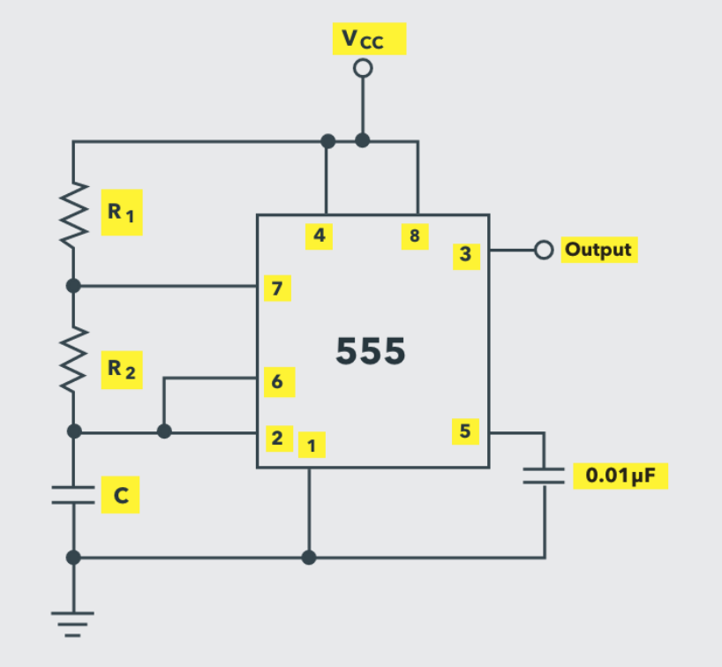

**Fig.1.1: The schematic of the IC 555 as an astable multivibrator**

The IC 555 can be made to work as an astable multivibrator with the addition of three external components: two resistors (R1 and R2) and a capacitor (C). The pins 2 and 6 are connected and hence there is no need for an external trigger pulse. It will self-trigger and act as a free running multivibrator (oscillator). The rest of the connections are as follows: pin 8 is connected to supply voltage (VCC). Pin 3 is the output terminal and hence the output is available at this pin. Pin 4 is the external reset pin. A momentary low on this pin will reset the timer. Hence, when not in use, pin 4 is usually tied to VCC.

The control voltage applied at pin 5 will change the threshold voltage level. But for normal use, pin 5 is connected to ground via a capacitor (usually 0.01µF), so the external noise from the terminal is filtered out. Pin 1 is ground terminal. The timing circuit that determines the width of the output pulse is made up of R1, R2 and C.

**PCB design:**

An electronic circuit consists of thin strips of a conducting material such as copper, which have been etched from a layer fixed to a flat insulating sheet called a printed circuit board, and to which integrated circuits and other components are attached.

In other words, a printed circuit board (PCB) or printed wiring board (PWB) is a laminated sandwich structure of conductive and insulating layers. PCBs have two complementary functions. The first is to affix electronic components in designated locations on the outer layers by employing soldering. The second is to provide reliable electrical connections (and also reliable open circuits) between the component's terminals in a controlled manner often referred to as PCB design.

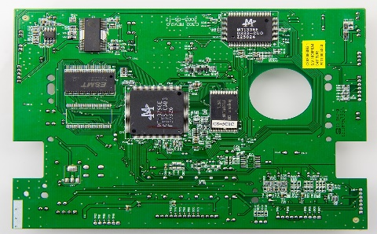

**Fig 1.2: PCB design**

A printed circuit board (PCB) mechanically supports and electrically connects electronic components using conductive tracks, pads, and other features etched from copper sheets laminated onto a non-conductive substrate. A printed circuit board has pre-designed copper tracks on a conducting sheet. The pre-defined tracks reduce the wiring thereby reducing the faults arising due to losing connections. One needs to simply place the components on the PCB and solder them.

Printed circuit boards are used in nearly all electronic products and in some electrical products, such as passive switch boxes.

Importance of PCBs design:

* People face problems while making a circuit on a breadboard like a circuit may work sometimes and may not work other times.
* Either the connection is not proper or loose or may get damaged while working or carrying the circuit on a breadboard.
* PCB made breadboard connection permanent.
* Mass-producing circuits with PCBs are cheaper and faster than with other wiring methods
* Before the advent of the PCB, circuits were constructed through a laborious process of point-to-point wiring. This led to frequent failures at wire junctions and short circuits when wire insulation began to age and crack

**Required Apparatus:**

* Proteas
* PCB board
* 555 Timer IC (NE555)
* Resistors (10KΩ-1piece, 1KΩ-1piece, 1KΩ-1piece)
* Capacitors (0.1µF-2pieces)
* LED Bulb (1piece)

**Circuit Diagram:**

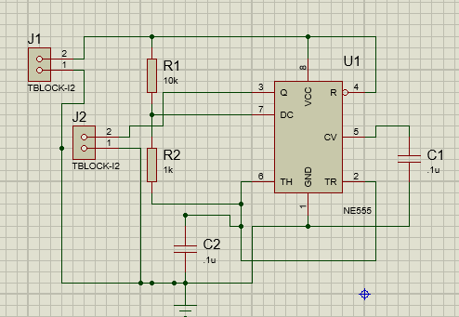

**Fig 02: Circuit diagram of an Astable multivibrator using 555 Timer (NE555)**

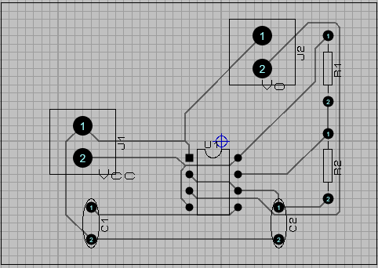

**Fig 03: Circuit diagram of an Astable multivibrator using 555 Timer (NE555) (PCB layout)**

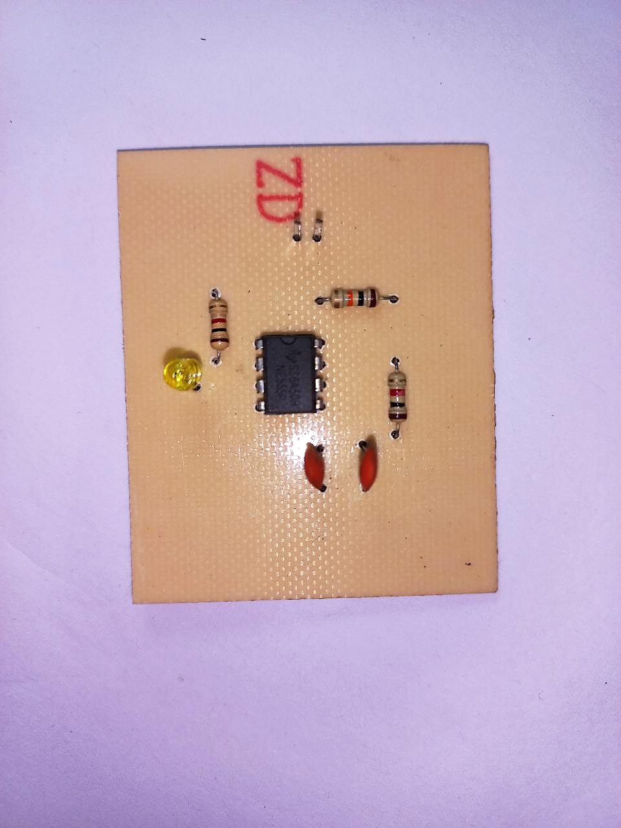

**Fig 04. Implemented circuit of an astable multivibrator using 555 timer with component (Top view)**

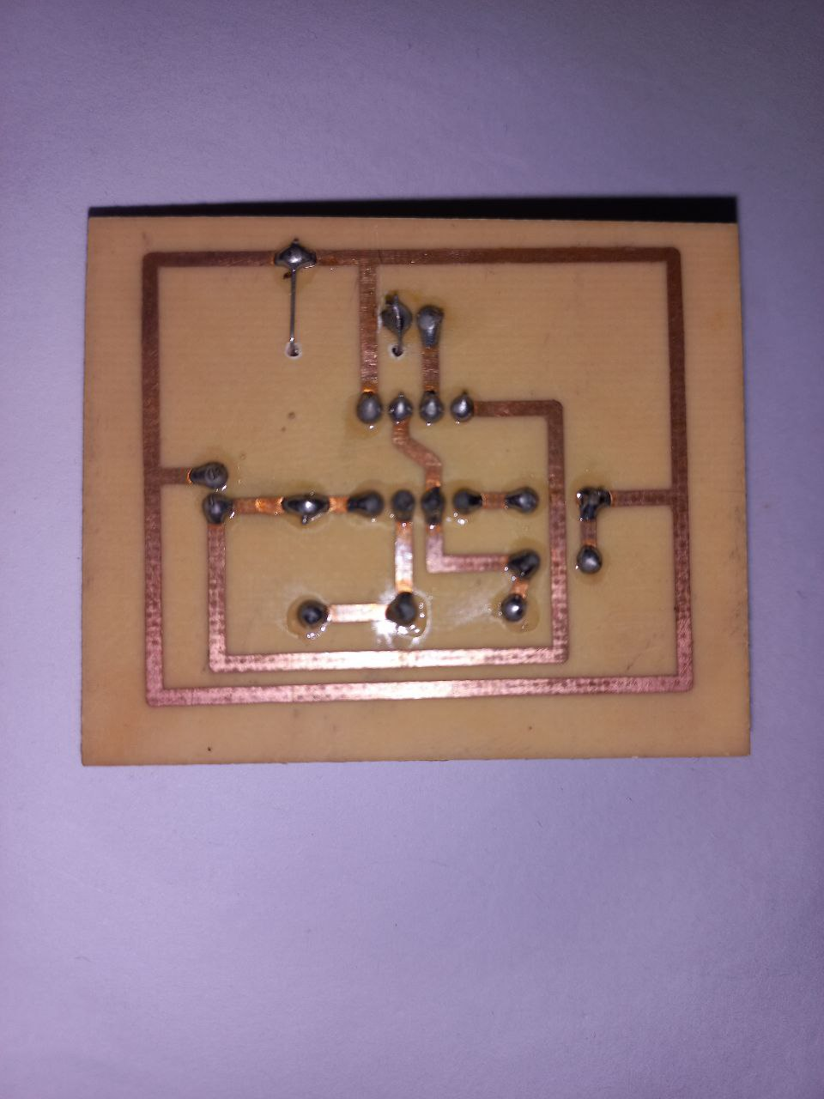

**Fig 05. Implemented circuit of an astable multivibrator using 555 timer with component (Bottom view)**

**Procedures:**

**Step 1: Design the circuit in Proteus platform:**

PCB design is usually done by converting your circuit’s schematic diagram into a PCB layout using PCB layout software. There are many cool open-source software packages for PCB layout creation and design. For this experiment, the very first step is to design the circuit of the astable multivibrator in the Proteus platform taking the appropriate components needed for the circuit. Then a PCB layout was created from the design.

**Step 2: Print from File to Film:**

The PCB layout was printed on special type of paper called Glossy or Photo paper and laser was used in that printing. The following points are carefully noticed,

1. The mirror print out was not taken.
2. The output in black both from the PCB design software and the printer driver settings.
3. Printout is on the glossy side of the paper.

**Step 3: Pressing the print on CCB board:**

The print of the design was pressed on copper clad board (CCB) using ai iron. After printing on glossy paper, iron its image side down to the copper side, then heat up the electric iron to the maximum temperature. Using pliers or a spatula, holding one end and keep it steady. Then putting the hot iron on the other end for about 10 seconds. Now, iron the photo paper all along using the tip while applying a little pressure for about 5 to 15 mins.

More attention was paid to the edges of the board – the pressure is applied and do the ironing slowly. Doing a long hard press seems to work better than moving the iron around.

The heat from the iron transfers the ink printed on the glossy paper to the copper plate.

**Step 4: Etching:**

Care was taken while performing the steps of etching.

* First, put on rubber or plastic gloves.
* Place some newspaper on the bottom so the etching solution does not spoil your floor.
* Take a plastic box and fill it up with some water.
* Dissolve 2-3 teaspoons of ferric chloride (FeCl3) power in the water.
* Dip the PCB into the etching solution (Ferric chloride solution, FeCl3) for approximately 30 mins.
* The FeCl3 reacts with the unmasked copper and removes the unwanted copper from the PCB.
* This process is called Etching. Using pliers to take out the PCB and check if the entire unmasked area has been etched or not. In case it is not etched, leaving it in the solution for some more time.
* Gently move plastic box to and fro so that etching solution react with exposed copper and form iron and copper chloride (cupric chloride, CuCl3)

As a result, the unwanted copper was removed that remained on the board. A chemical solution, similar to the alkaline solution was used to remove the unwanted copper.

**Step 5: Drilling:**

Holes were drilled into the layers by a drill machine to expose the substrate and inner panels. Any remaining copper after this step was removed.

**Step 6: Soldering:**

Soldering is a process in which two or more metal items are joined together by melting and flowing a filler metal (solder) into the joint, the filler metal having a lower melting point than the workpiece. Solder is a metal alloy (generally) usually made of tin and lead which is melted using a hot iron. The iron is heated to temperatures above 600 degrees Fahrenheit which then cools to create a strong electrical bond.

Here, the components were placed on the CCB according to the design of the astable multivibrator. Soldering, iron, sucker, resin, soldering wire such. components were used during soldering.

**Step 7: Testing:**

Finally using power supply and oscilloscope the design was tested that it works properly or not.

**Observation:**

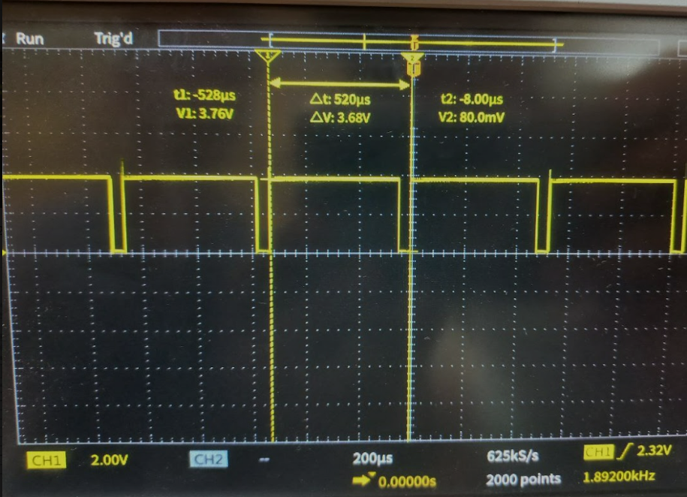

**Fig.06: Output Waveform of Astable Multivibrator**

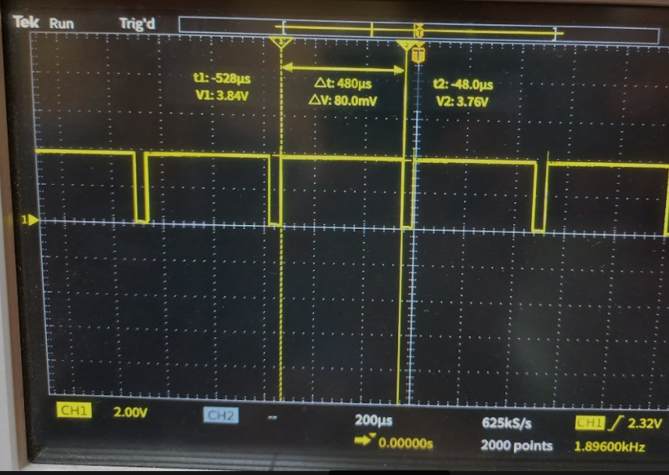

**Fig.07: Time period of higher state of output**

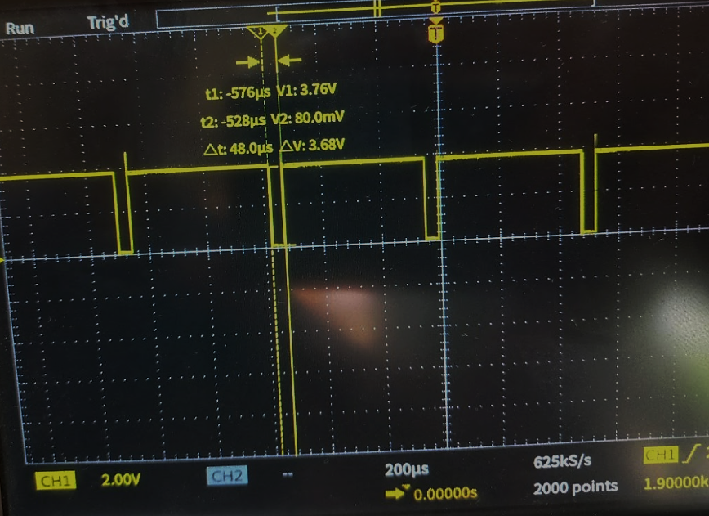

**Fig.08: Time period of lower state of output**

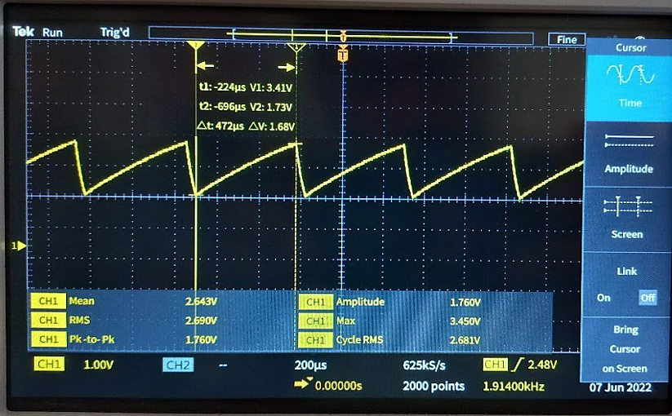

**Fig.09: Charging time period of capacitor**

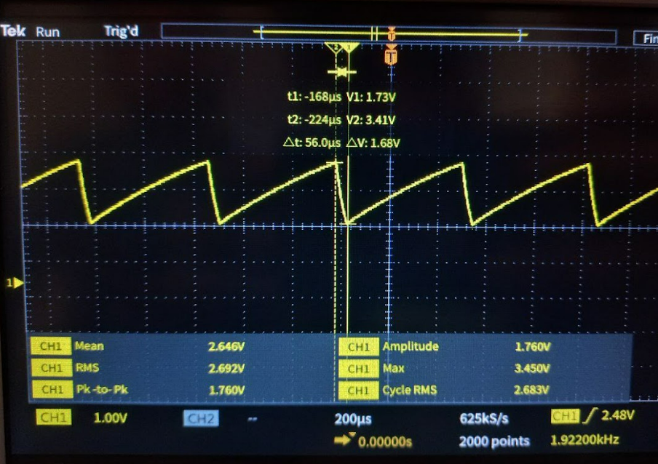

**Fig.10: Discharging time period of capacitor**

**Discussion and Conclusion:**

In that experiment an astable multivibrator circuit was designed and the operation and different characteristics of the circuit were observed. No input was used in that circuit as astable multivibrator is a free running circuit. The output was high during the charging period of the capacitor and the output was low or zero during the discharging period of the capacitor.

Some difficulties were faced by us designing the PCB regarding the printing paper. It is very important to print the design on appropriate paper. Following the processes very carefully after having some errors the experiment was done successfully at last.